KARY HUANG

CIS3400 – FTRA

05/11/2016

SQL Assignment Revised

**Q2**

CREATE TABLE Customer

(

C_Num text(4) NOT NULL,

Cname text(30),

City text(20),

IndustryType text(1),

YTDSales money,

PRIMARY KEY (C_Num)

);

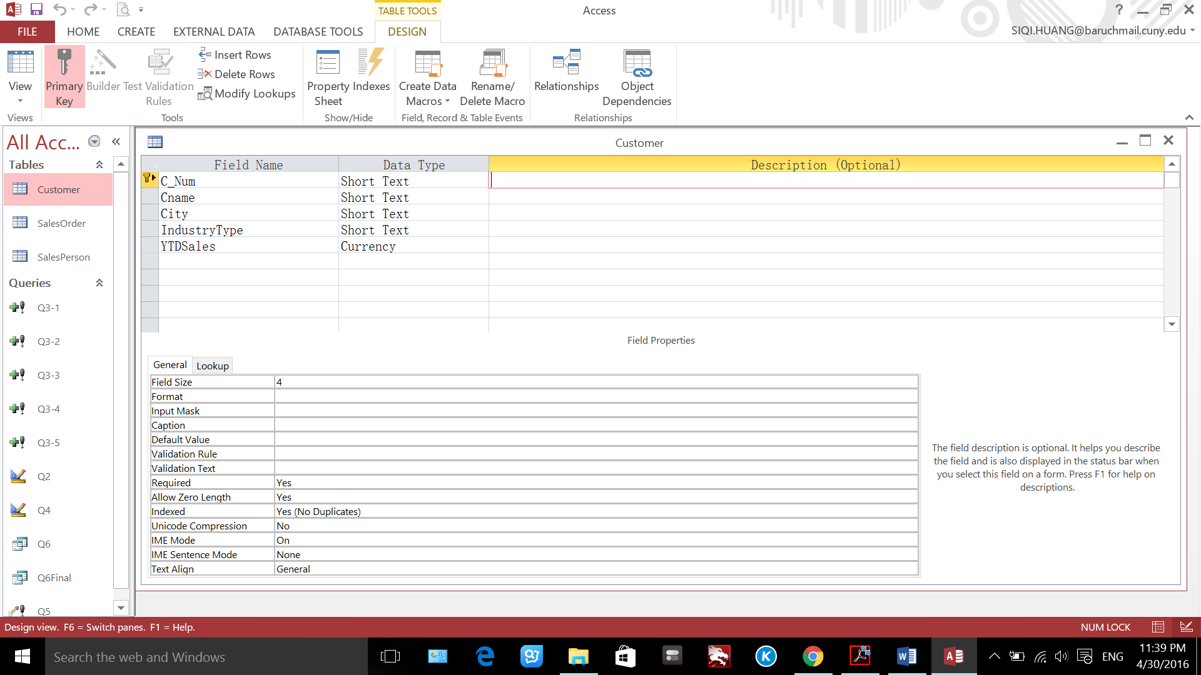

Q3

INSERT INTO Customer ( C_Num, Cname, City, IndustryType, YTDSales )

VALUES ("C105", "Delphi Developers", "Astoria", "P", "149000.00");

**Q4**

ALTER TABLE Salesorder

ADD CONSTRAINT addfk

FOREIGN KEY (C_Num) REFERENCES Customer (C_Num)

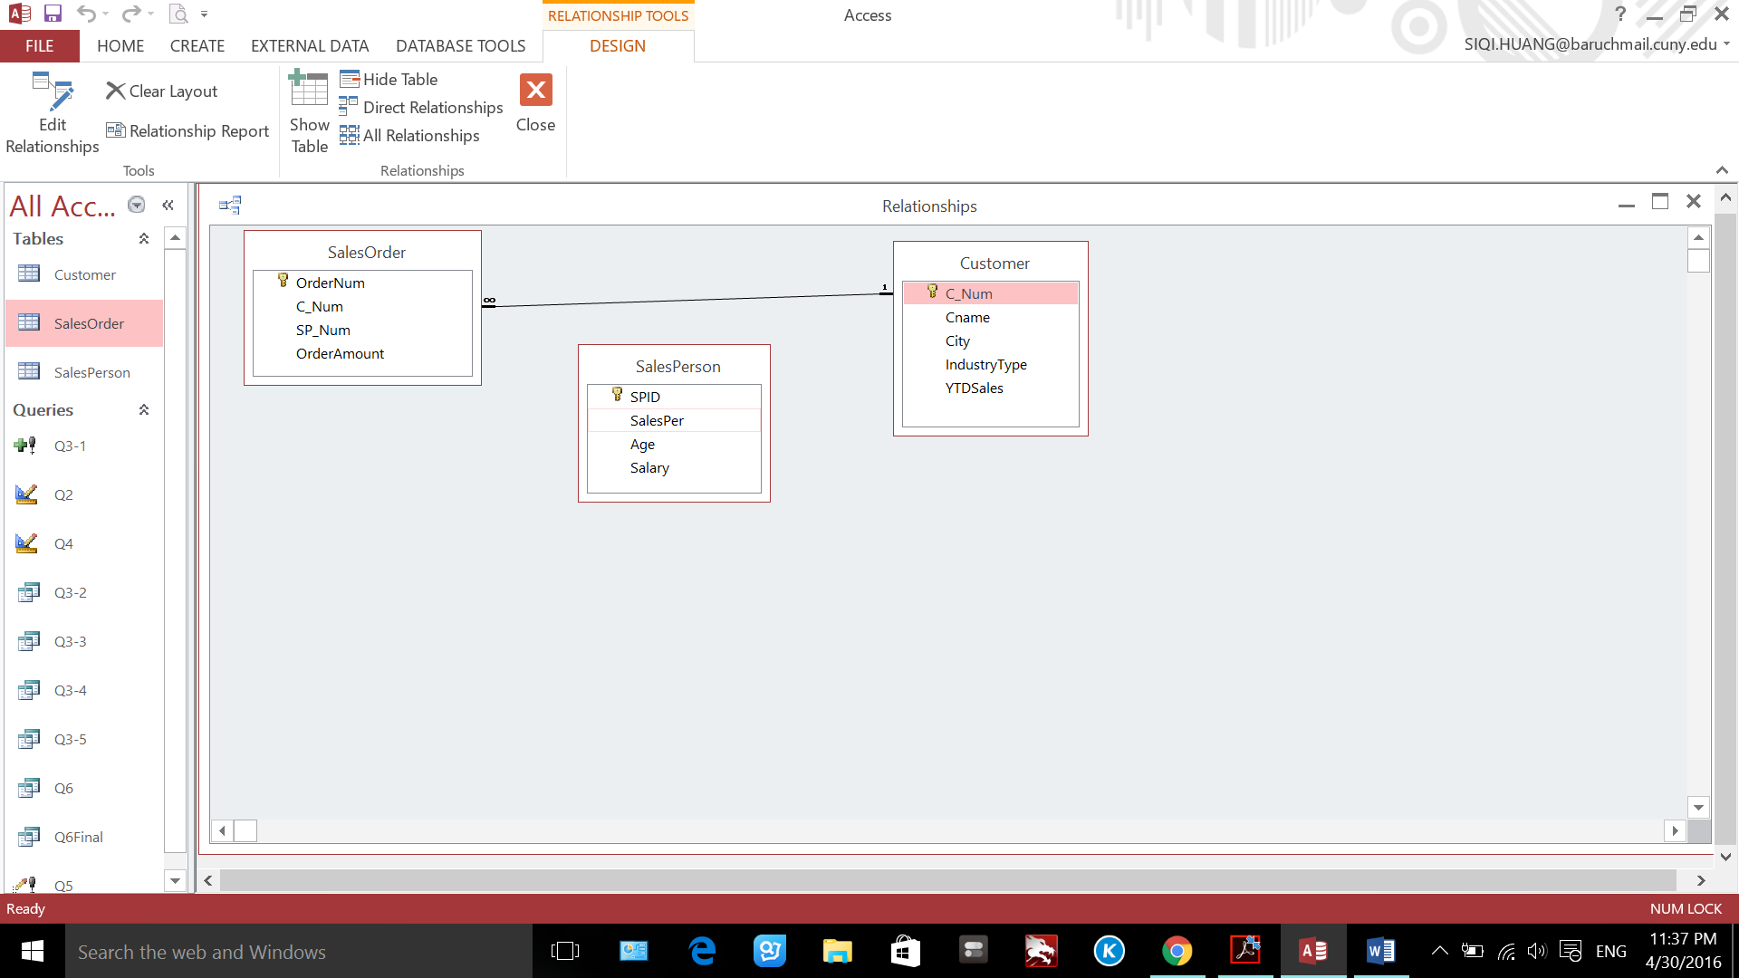

**Q5**

UPDATE SalesPerson SET salesper = "Kary"

WHERE SPID = "Y66";

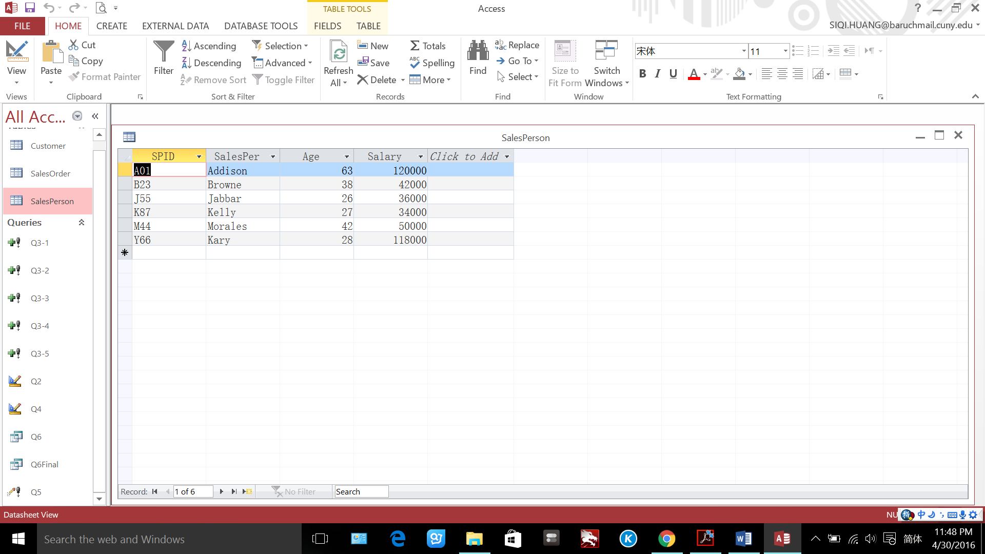

**Q6**

SELECT *

FROM Customer AS C INNER JOIN SalesOrder AS S ON C.C_Num = S.C_Num;

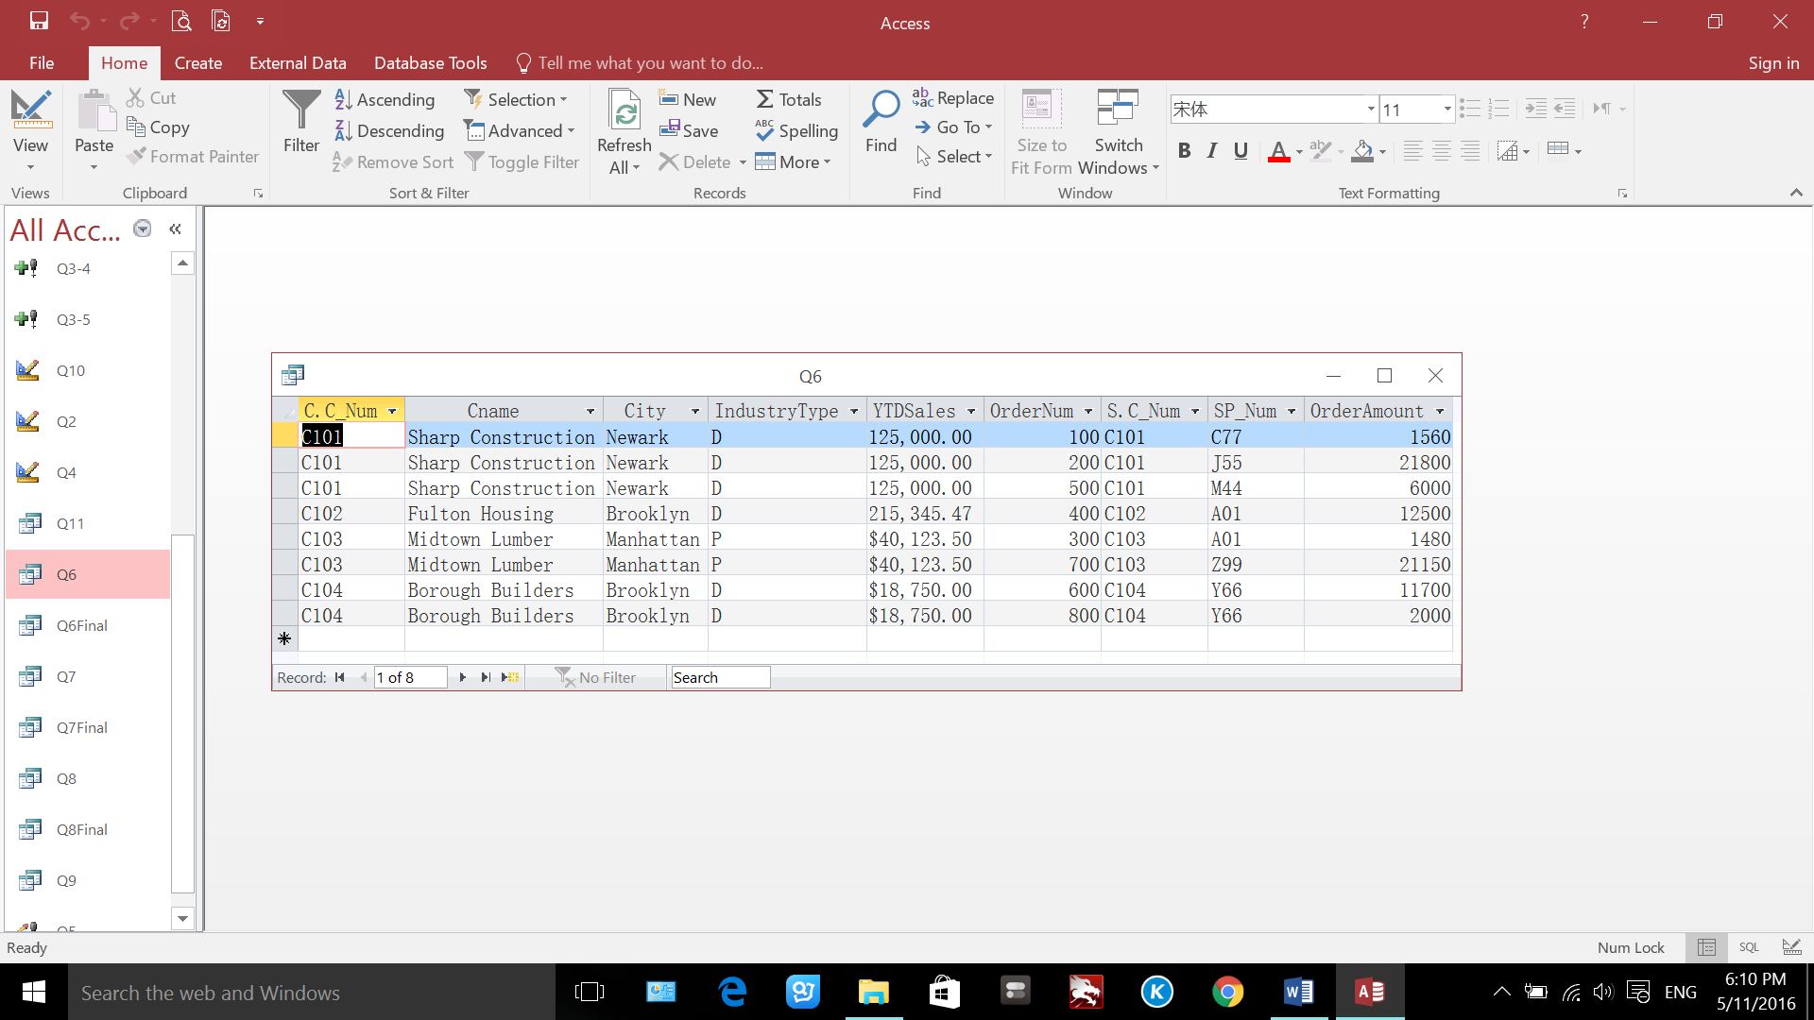

SELECT OrderAmount , Cname, City, SP_Num

FROM Q6

WHERE City = 'Brooklyn' AND OrderAmount > 10000

ORDER BY OrderAmount DESC;

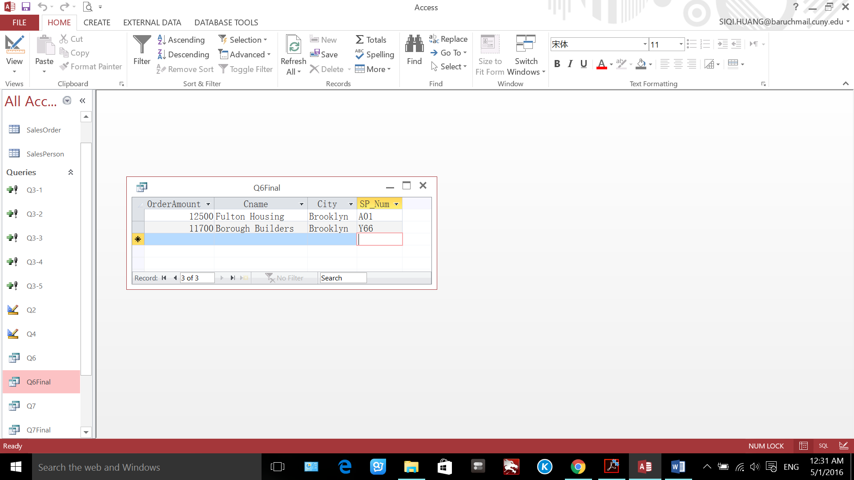

**Q7**

SELECT *

FROM SalesPerson AS S INNER JOIN Q6 AS Q ON S.SPID = Q.SP_Num;

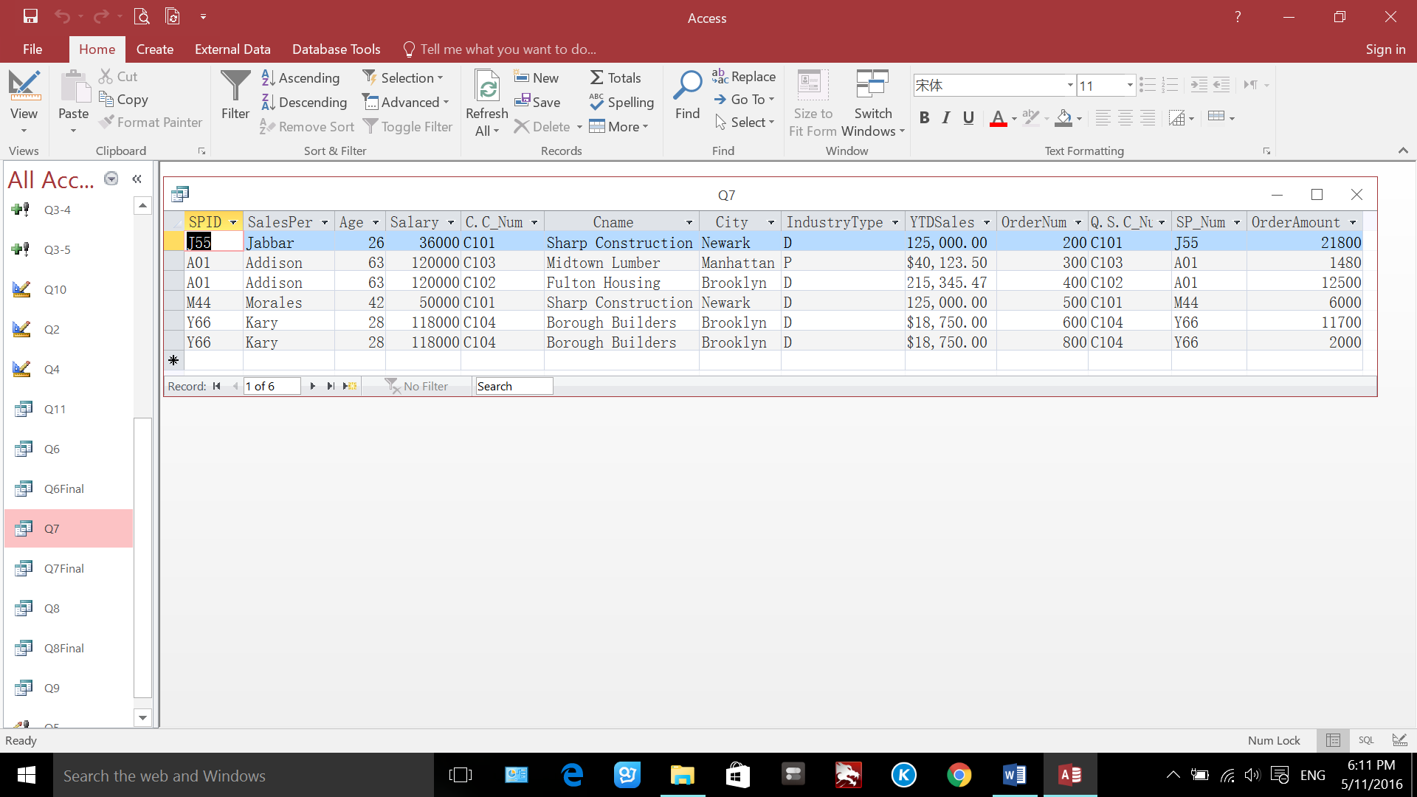

SELECT SalesPer, Salary, Cname, OrderAmount

FROM Q7

WHERE Cname = 'Sharp Construction' OR Cname = 'Borough Builders'

ORDER BY SalesPer;

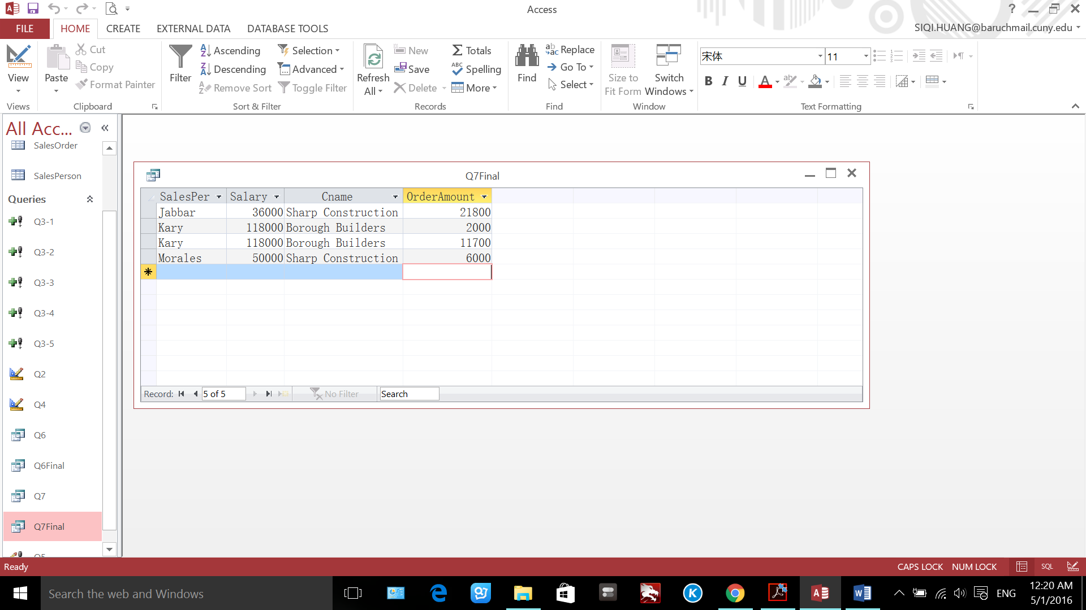

**Q8**

SELECT *

FROM Customer AS C LEFT JOIN SalesOrder AS S ON C.C_Num = S.C_Num;

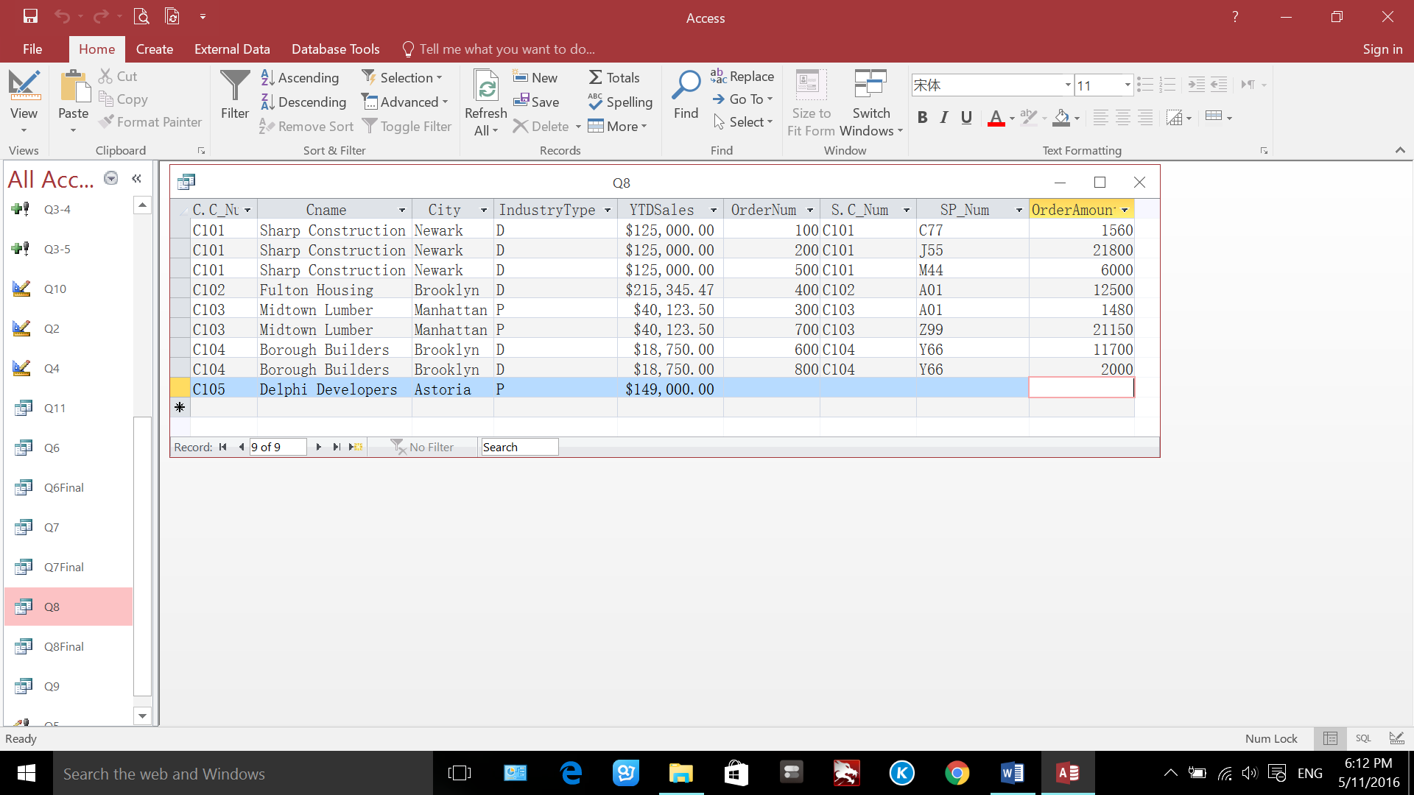

SELECT Cname, C.C_Num, OrderNum, OrderAmount FROM Q8

ORDER BY Cname ASC;

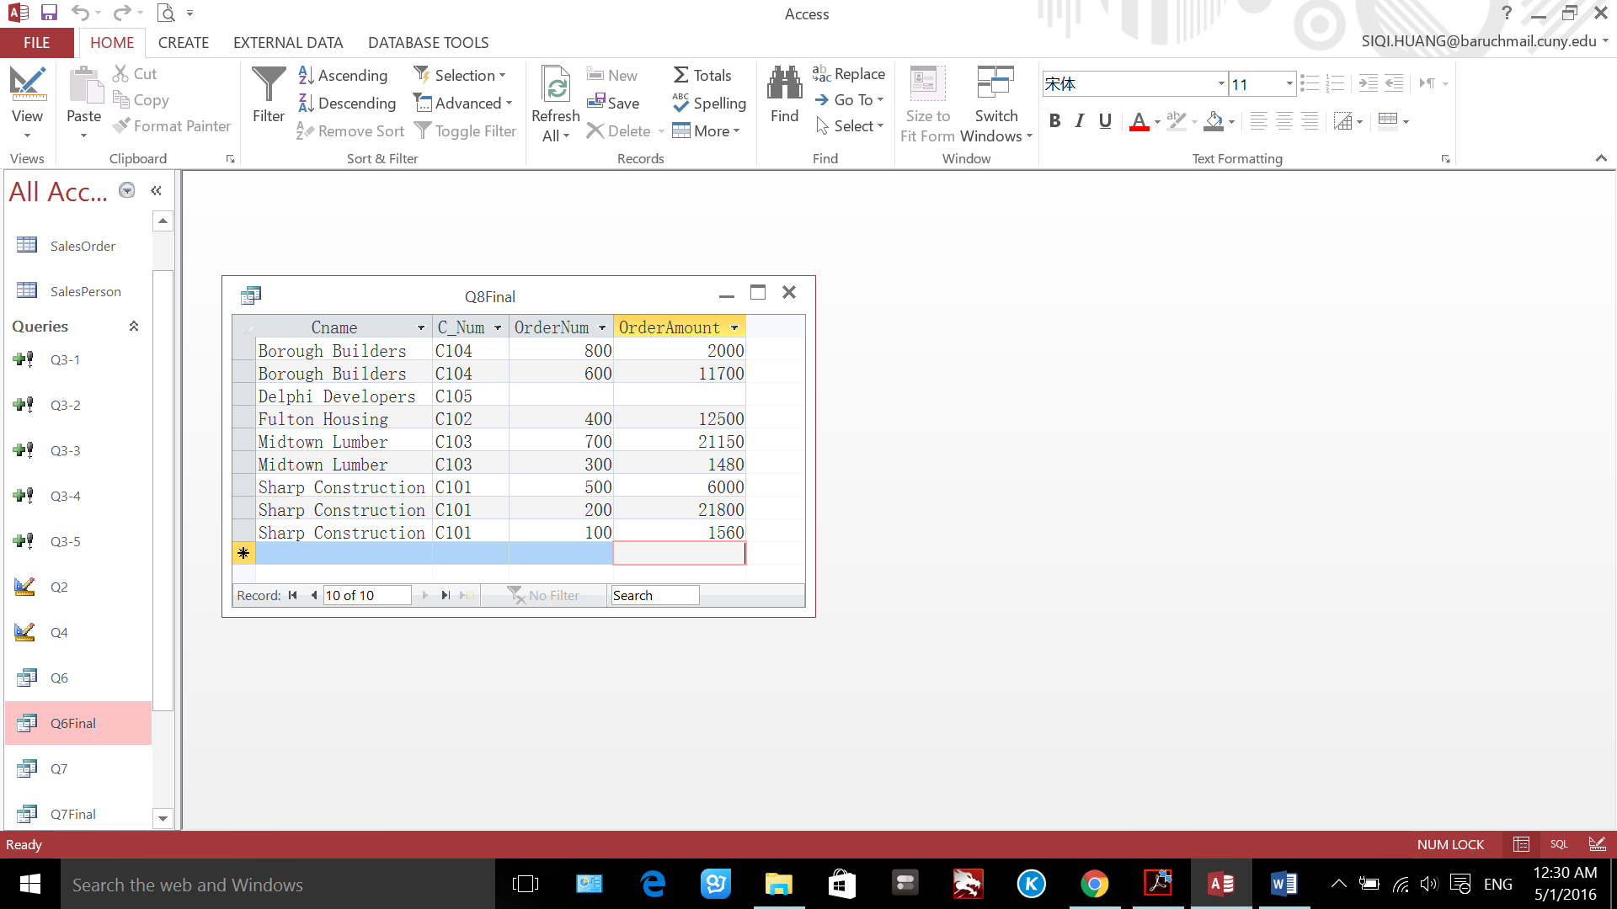

**Q9**

SELECT "Kary" AS SalesPerson, Count(SalesPer) AS Num_of_Orders, Avg(OrderAmount) AS AvgOrderAmount FROM Q7

WHERE SalesPer = 'Kary';

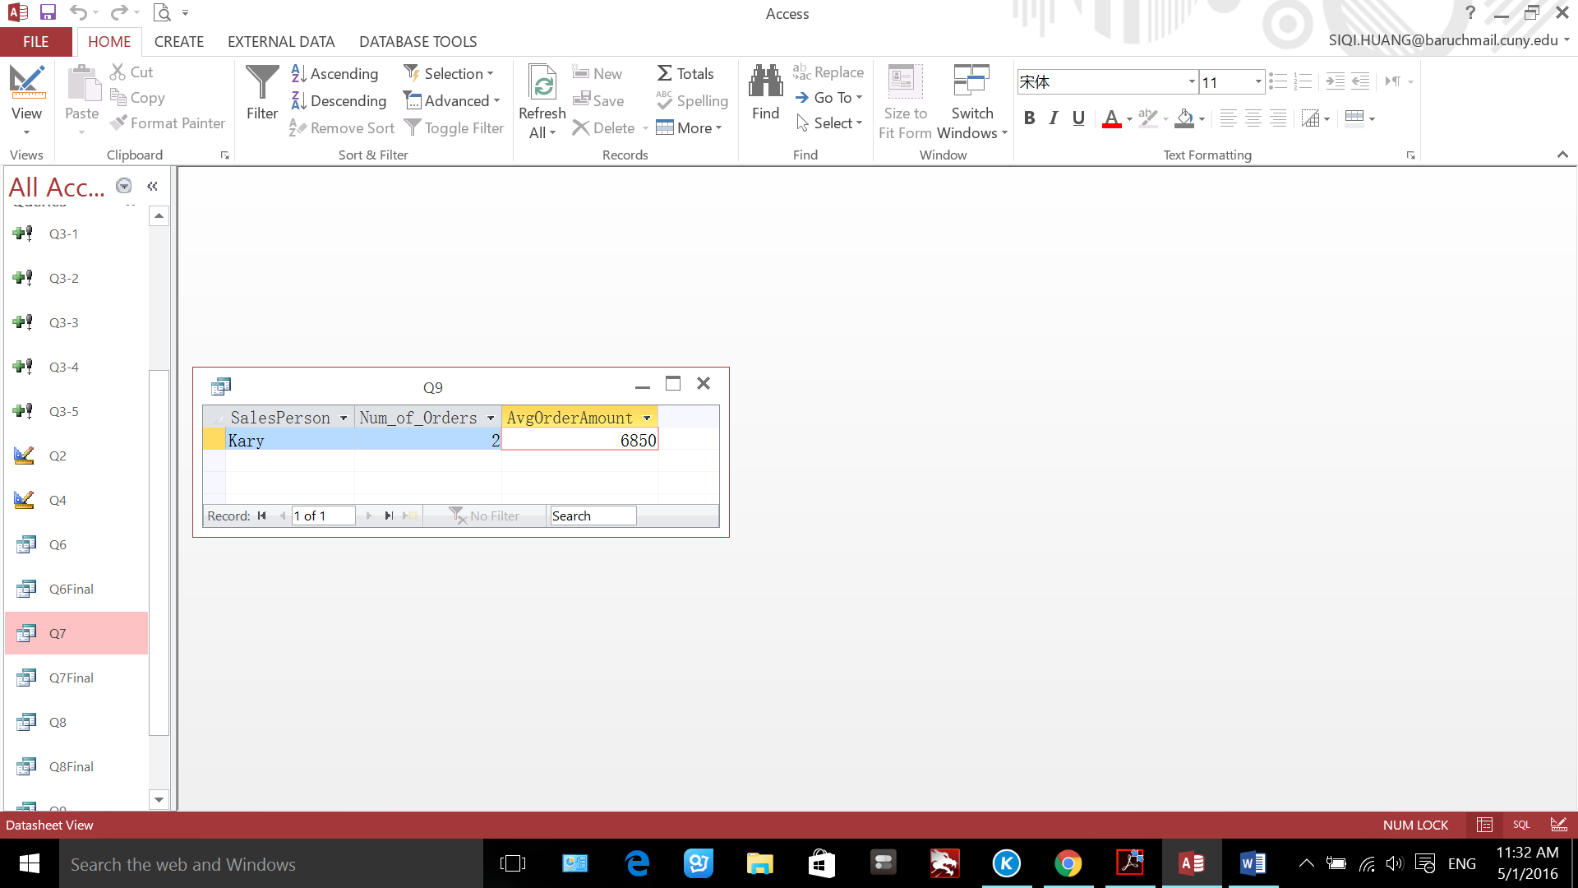

**Q10**

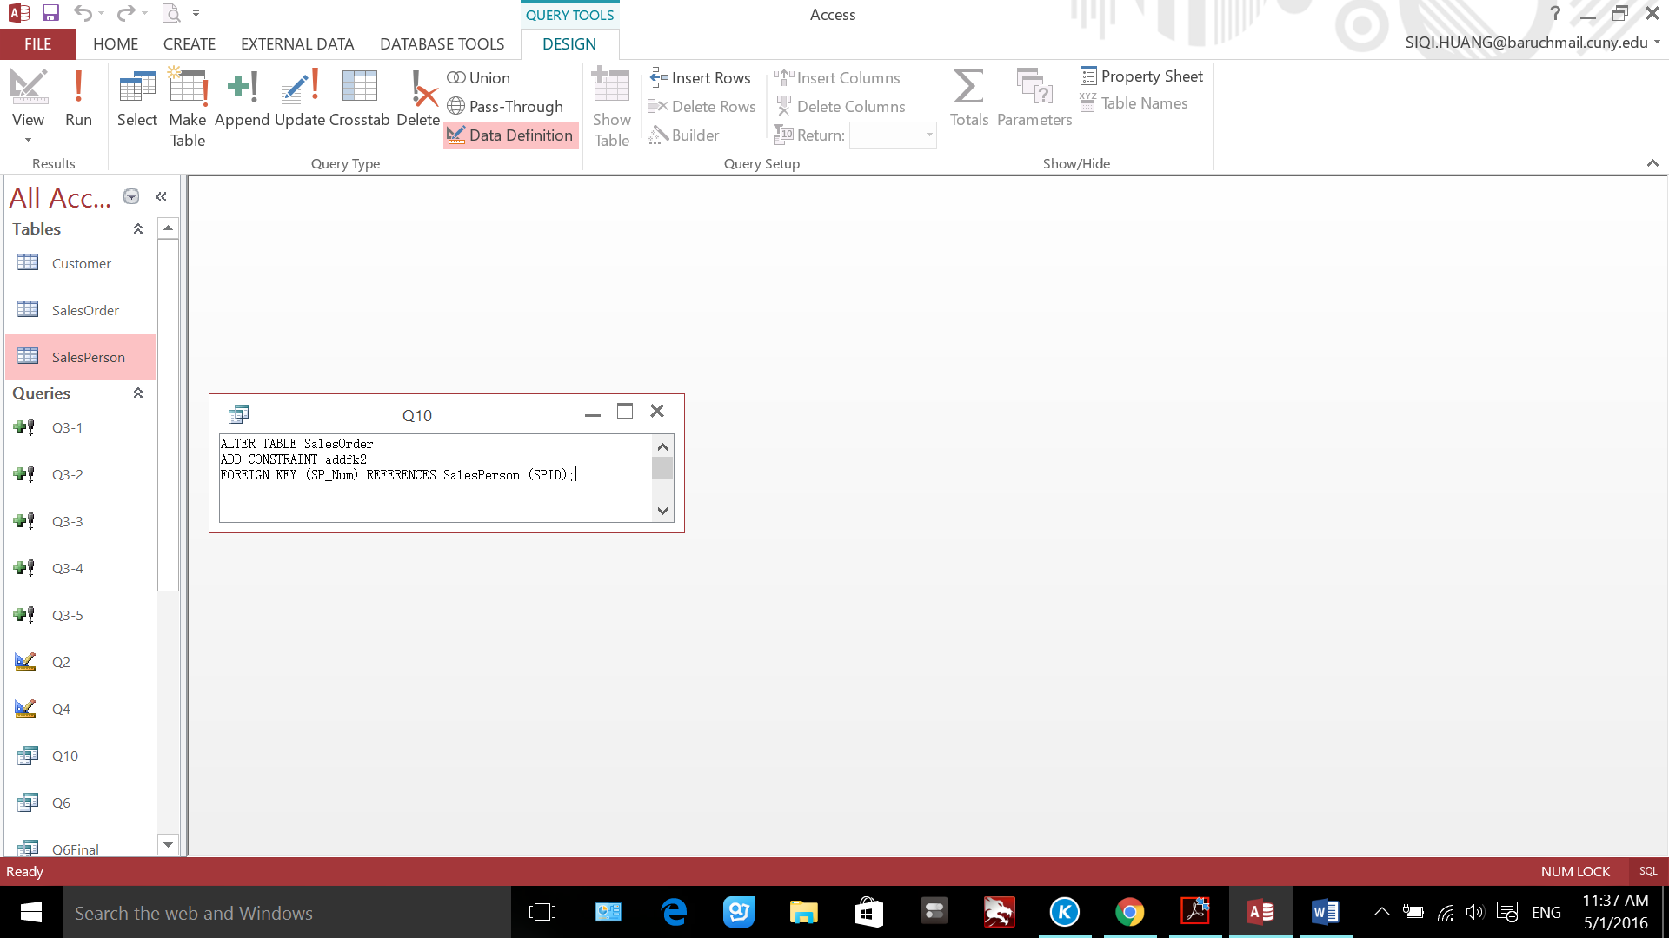

Error message: Cannot create relationships to enforce referential integrity. Existing data in table ‘SalesOrder’ violates referential integrity rules in table “SalesPerson’.

Reason: The foreign key constraint cannot be created because SPID does not contain all the data in SP_Num; C77 and Z99 in SP_Num has nowhere to link to in SPID.

**Q11**

SELECT C_Num, Cname, City, IndustryType, YTDSales FROM Customer AS c1

WHERE c1.YTDSales = (SELECT max(c2.YTDSales) FROM Customer AS c2 where c1.IndustryType = c2.IndustryType);

